

**RASD**

Software Engineering 2 AA 2016 - 2017

**Botta Daniel Enrico**

**Bruschi Agnese**

**Cano Adriana**

Index

**1 Introduction3**

1.1 Description of the given problem3

1.2 Purpose3

1.3 Scope4

1.3.1 Domain properties4

1.3.2 Assumptions5

1.4 Definitions, Acronyms, Abbreviations7

1.5 Overview9

1.5.1 Proposed System9

1.5.2 Identifying stakeholders9

**2 Actors identifying9**

3 Specific Requirements10

3.1 Functional Requirements10

3.2 Non Functional Requirements12

3.2.1 Non Functional Requirements12

3.2.2 User Interface12

4 Scenarios13

4.1 Identifying scenarios13

5 UML Models16

5.1 Use cases description17

* + 1. Register17
    2. Login15
    3. Visualize profile15
    4. Modify personal information15
    5. Search for a car15
    6. Reserve a car15
    7. Pick up a car15
    8. Cancel reservation15
    9. Pending state option15
    10. Money saving option15
    11. Payment15
    12. Field operator work15

Appendices

Index

**1 Introduction**

In this section we will introduce the problem we were addressed with and the stakeholders we answer to. We will describe the main objectives that will be taken into account, the world properties and the overall assumptions that were made to treat the problem.

**1.1 Description of the given problem**

The system to be developed is PowerEnJoy, a digital management system for car-sharing service that exclusively employs electric cars.

The system main service is to allow registered users to search for available cars within a certain distance from a given position (the user current location or a specified address). The user should be able to reserve the available cars up to an hour before the reservation time and should be allowed to pick it up for an hour after the said time. There are no time limitations on the duration of the reservation.

Given the user’s behaviour during the rental, the system should grant discounts or apply extra fees. The system should also provide a special money saving option which would allow the user to save money and realize a fairer distribution of cars around the city.

**1.2 Purpose**

After analysing the stakeholder’s requests, we identified the following goals for our system.

PowerEnJoy should provide these features for the **user**:

**[G.1]** Allow users to search for available cars within walking distance from their current location or from a specific address.

**[G.2]** Allow users to reserve an available car.

**[G.3]** Offer a money saving option that allows the user to gain discounts.

**[G.4]** Charge the user with a fee at the end of the service.

**[G.5]** Encourage the users to cooperate to improve their overall experience.

PowerEnJoy should provide these features for the **operator**:

**[G.6]** Notify that a car needs charging, it’s damaged or malfunctioning.

**1.3 Scope**

**1.3.1 Domain properties**

The following properties will hold in the model designed by us.

**[D.1]** A user can enter in a car only if the car is unlocked.

**[D.2]** To ignite the engine, the driver must press the power button when the car is off.

**[D.3]** To switch off the engine the driver must press power button when the car is on.

**[D.4]** Each car has a socket where the car charger can be plugged in.

**[D.5]** Every car is equipped with sensors that can tell:

* + the number of people in the car
  + if the car has suffered consistent external damages
  + if the car suffers internal damages
  + the battery charging state

**[D.6]** Every car is equipped with an external display to insert the reservation code.

**[D.7]** Each car offered has five seats.

**1.3.2 Assumptions**

Some facts or descriptions are not mentioned or ambiguous in the document, so we will assume some of them.

**[A.1]** The system is able to check the correctness of the facts stated by the user over:

* Email: can check the validity of an e-mail address
* Driving licence: can check the existence and belonging of the driving licence ID. Name and surname of the user must match the driving licence name and surname.
* Credit card: can check the legitimacy of the credit cards information.
* Credentials: can ensure the existence of the address

**[A.2]** When a driving licence or a credit card expires, the system temporarily disables the account, sending an e-mail to the user, to notify him/her the fact.

The account will be reactivated once the user updates the expired credentials with valid ones.

**[A.3]** If the credit card is not able to cover the costs of the fee, the system is able to detect it.

* + The system will send an e-mail to inform the user that its payment was unsuccessful.
  + The services will be disabled until the payment is confirmed.
  + The user has 24 hours to replace the credit card.
  + Eventual payments failures and problems will be handled by external partners.

**[A.4]** Every mail sent always arrives to the designated address.

**[A.5]** The user’s clock is in tune with the time zone of his location.

**[A.6]** The system allows the user to *freeze* its reservation:

* + for up to two hours
  + The user is charged with a lower, constant fee per minute.
  + If the user does not come back after two hours, the system ends the reservation, calculates the fee
  + if the car is parked in a safe area when the reservation expires, the user is charged with an extra fee and the car is settled as available again
  + if the car is parked in a non-safe area when the reservation expires, the user is charged with an extra fee and an operator is called to move the car to a safe area.

**[A.7]** The system discourages the user to park outside the safe area by keeping active the charging system if the user leaves.

**[A.8]** The system generates a unique reservation number for each reservation made.

**[A.9]** The user has a *working phone*.

**[A.10]** The system employs field operators. Each field operator has his own profile. Fields operators can:

* + log in the profile
  + check notifications
  + confirm resolution of problems

**[A.11]** Car issues are handled by the field operators.

Issues include**:**

* Car not parked in a safe area
* Low battery
* Eventual interactions with third parties

**[A.12]** At the end of each reservation, the sensors check the state of the car. If any suspicious value is found, the car informs the system, which sends a notification to the operator.

The system informs the field operator through a notification on his profile.

**1.4 Definitions, acronyms, abbreviations**

**Guest**  A person who has yet to sign up to the system. Cannot use any functionality apart from registering to the system.

**User**  Person registered to the system. To register into the system, the following information is given:

* 1. *Credentials*: name, surname, address.
  2. *Driving Licence*: ID, Name and Surname of the driver, expiring date of the licence.
  3. *Credit Card*: name and surname of the possessor of the card, card number, card expiring date, CVV.

**Reservee**  User who has reserved a car.

**Reservation time**  Time of reservation of a car.

**Reservation code**  Code given to the user once he has reserved a car. It is needed to unlock the car. (7 digits code).

**Freeze** The car is freezed when the reservee, that is already using it, parks and decide to stop for a certain amount of time, all while still reserving the car. .

**Safe area** Area predefined by the management system where the user can park the car once he/she has finished using the service.

**Travellers** Driver and passengers.

**Locked / Unlocked** When the travellers exit the vehicle the car is in a locked state. To unlock it the user must insert the same reservation number.

**Sound**  A user is sound if he has reserved a car and if the current time satisfies this inequality:

reservation_time < current_time < reservation_time + 1h

**Uniform distribution of cars**: the system aims to provide a distribution of cars that ensures the best possible coverage of the city, so that the possibility that a user finds a car near the defined address is higher.

**Walking distance** A distance that would take up to 10 minutes to reach on foot.

**Working phone** A phone that has the GPS signal and internet connection working correctly and the PowerEnJoy app installed.

**Coherent car** A car is coherent with a search if it’s available and it its position is within the range of the search.

**Car labels:**

* **AVAILABLE:** Car that is not reserved and that is parked in a safe

area.

Can be reserved by users.

* **RESERVED:** Car is already reserved and waiting to be used.
* **IN USE:** The reservee is using the car.
* **PENDING:** The reservation is frozen.
* **MAINTENANCE:** The car has an internal or external damage that

needs to be dealt with or car needs to be recharged by an operator.

Either way, the car will be marked as AVAILABLE again once the specific problem has been dealt with.

**Reservation states:**

* **VALID:** A reservation is VALID when the car is reserved

and the user is still in time to pick it up.

* **CONFIRMED:** A reservation is CONFIRMED when the user enters

the car and ignites the car.

* **FROZEN:** A reservation is FROZEN when the PENDING

option is chosen. The car must be parked and

turned off.

* **COMPLETED:** A reservation is COMPLETED when the payment

has been successfully concluded.

* **CANCELED:** A reservation is CANCELED by the user (at least

10 minutes before the reservation time) or by the

system.

**1.5 Overview**

**1.5.1 Proposed System**

We propose a mobile application that will be able to give users the power to enjoy driving through the city.

Users will be able to reserve cars through the application, using a simple interface via touchscreen. To access any service offered by the system they shall first register to the system. In the profile created, the user can change the information provided. The users will be able to search for available cars in the chosen area, and to reserve the one that they prefer. They also have the possibility to modify their reservations or cancel them.

**1.5.2 Identifying Stakeholders**

We consider the main stakeholder the professor, to whom we will deliver the document.

For the first document, the RASD, we are required to describe the goals of our project, identify the domain properties and determine the requirements that will regulate our system behaviour. Moreover, we will analyse the different use case scenario and fully describe the components that will constitute the body of the application, deepening our evaluation describing the functionalities with Alloy.

We will focus first on the main functionalities of the system, then we will deepen our description, trying to cope with every aspect of the system that may improve the user’s experience of the application. Starting from this last consideration, we can imagine that a theoretical stakeholder for our system could be a company that would have asked us to realize an application to give the chance to users to benefit PowerEnJoy car service functionalities.

**2. Actors Identifying**

The actors of our informative system are the following:

* **GUEST :** A person who has yet to sign up to the system. Cannot use any functionality offered by the system.
* **USER:** A person who is registered to system, he is in possession of a verified driving license and a valid credit card.
* **FIELD OPERATOR** : employee at service of the system.

**3. Requirements**

Requirements are the shared phenomena between the real world and our software-to-be that can be used by the machine to control the events to achieve the goals.

Requirements can be functional or non-functional.

**3.1 Functional Requirement**

A functional requirement is necessary to describe the correct functioning of the system.

**Management of the user’s profile:**

These requirements are essential to reach the goals, but do not belong to a specific one.

As a matter of fact, to achieve every goal required the user must be registered and able to modify and visualize his/her profile.

**[F.R.1]:** A guest can benefit the application’s services only if he/she is registered.

**[F.R.2]**: A user’s registration is confirmed if and only if his/her credentials match the credentials associated to the driver licence inserted.

**[F.R.3]**: A user should be able to log in in the system.

**[F.R.4]:** A user can log in if and only if he/she inserts the right combination of e-mail address and password.

**[F.R.5]:** A user should be able to request a password recovery.

**[F.R.6]:** A user should be able to update his/her payment method.

**Search of a car [G.1]**:

**[F.R.7]:** A user can search a car if and only if he/she is registered.

**[F.R.8]:** The system shows to the user only the cars that are coherent with his/her search.

**[F.R.9]:** A car is coherent with a search if and only if it’s available and its position is within the search range.

**[F.R.10]:** A car can be selected if and only if it’s shown in the search.

**[F.R.11]:** A selected car can be reserved.

**Management of car reservation [G.2]:**

**[F.R.12]:** A user can reserve a car if and only if there is not another car reserved by him/her in the desired time interval.

**[F.R.13]:** To reserve a car the user must insert the reservation time.

**[F.R.14]:** The reservation time must be: tRESERVATION <= tCURRENT + 1 Hour

**[F.R.15]:** The picking up time must be: tPICKUP <= tRESERVATION + 1 Hour

**Pick up the car [G.2]:**

**[F.R.16]:** A reserved car is unlocked if and only if the correct *reservation code* is inserted.

**[F.R.17]:** A car parked in a safe area is locked if there are no travellers in the car.

**Money Saving Option [G.3]:**

**[F.R.18]:** The money saving option provides the address of the station near the destination address which will guarantee a discount.

*The station will be chosen taking into account the distribution of cars around the city and the capacity of the stations. The calculation will be handled by an external system.*

*The discount is not assured, until the car is actually parked in the station and connected to the power grid.*

**Payment [G.4] [G.5]:**

**[F.R.19]:** The system calculates the fee once the ride is concluded.

**[F.R.20]:** The ride is concluded when the user parks in a safe area, turns off the car and exits from the car without choosing the freeze option.

**[F.R.21]:** The fee is calculated based on a fixed amount of money per minute.

*The amount of money to be paid is chosen by the administrators of the system.*

**[F.R.22]:** Before applying the fee, the system checks if the ride is eligible for a discount.

**[F.R.23]:** If for the whole ride there were more than three travellers, the system applies a 10% discount.

**[F.R.24]:** If the user connects the car to a power grid of one of the special parking areas after the ride, the system applies a 30% discount.

**[F.R.25]:** If the user leaves the car with more than 50% of the charge left, the system applies a 20% discount.

**[F.R.26]:** If the user leaves the car more than 3 km away from the nearest power grid station, the system charges him/her 30% more.

**[F.R.27]:** If the user leaves the car with less than 20% of the charge left after the ride, the system charges him/her 30% more.

**Operator [G.6]:**

**3.2 Non-Functional Requirements**

**3.2.1. Non Functional Requirements**

**[N.F.R.1]:** The server should be available 24 hours a day, 7 days a week.

**[N.F.R.2]:** The field operators must be available throughout the whole availability period.

*This means that they will be required to take turns.*

**3.2.2 User Interface**

The user will be able to interact with the system through an interface which will allow him to perform all the requested activities.

The first page that the interface will show is a log in / sign in page.

**Log in:**

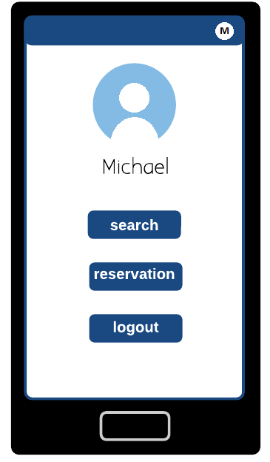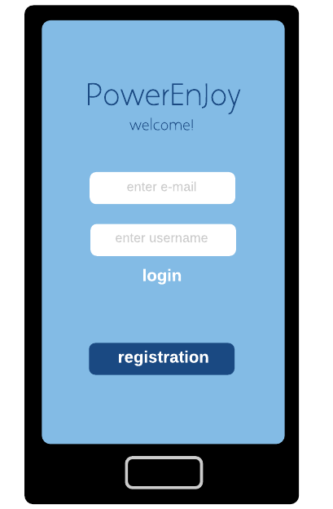

Figure 3.A

When the user accesses to the system, he / she is able to choose between the following services:

* Press the top right button, which will show the personal profile with all the data. This will allow the user to keep updated all his / her personal information and the payment and driving licence data.
* Start a search
* Log out
* Check the current reservation.

**Search:**

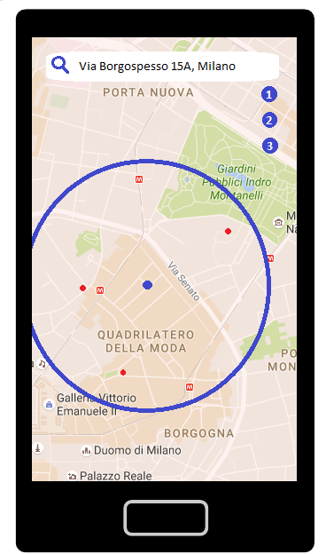

Figure 3.B

**4.1 Scenarios Identifying**

[SCENARIO 1]

Michael has a driving license but doesn’t have enough money to buy his own car. He searches for various options on the internet and finds PowerEnjoy. After reading how it works, he decides that he wants to try it out, and decides to download the application on his smartphone. He makes the first step in order to create an account. A form which he must complete. He must insert the following personal information: name, surname, e-mail, phone number, driving licence number, credit card number. The system accepts his registration and Michael can visualize his personal page.

[SCENARIO 2]

Michael is interested to utilize PowerEnjoy. So he goes onto the application and searches for a Car using the “Search for car” service. He turns on his GPS and selects the radius distance. The system then shows him on the map the available cars in the designated area.

After some thinking he selects the best option for him, chooses a time and the system reserves the car for him sending him a reservation code. Michael presents himself at the car at the specified time, goes on his mail account and looks at the reservation code. He can now unlock the car with it and drive.

[SCENARIO 3]

Michael has reserved in advance a car but being a busy man he has many appointments to keep track of. He realizes that he has reserved a PowerEnjoy car at the time of his meeting, and so he couldn’t pick it up. He decides to cancel the reservation, going to his profile and choosing the “Cancel reservation” option.

[SCENARIO 4]

Michael has reserved a car. He decided to get some sleep before he had to hit the road. He clumsily overslept and didn’t manage to make it in time to pick up the car. A notification arrived to his phone informing that 1 EUR would be deducted from the credit card due to the fact that he reserved a car without picking it up.

[SCENARIO 5]

Michael has changed some of his personal information and would like to update them in the PowerEnjoy app. He goes into his profile and can modify manually the credentials he desires. The system will verify if the changes are valid. If not the system will refuse them.

[SCENARIO 6]

Michael has to do some routine shopping. He realizes he can use a PowerEnjoy car to make things easier. He travels to the shop and parks in a non safe area. He puts the car in a “Pending” state. This reduces the fee per minute and can be used for a maximum of 2 hours per ride. Once he returns he can unlock the car and put the car back in “InUse” state.

[SCENARIO 7]

Karen and Robert, Michael’s best friends, want to go out with him but don’t have a driving license. Michael decides to use the PowerEnjoy app. After he has reserved a car and that the specified time has arrived, Michael, Karen and Robert get in the car. The system detects via sensors that there are 2 passengers in the car and informs Michael through notification one his phone that he will receive a 10% discount on the last ride.

[SCENARIO 8]

Michael is driving on board of a PowerEnjoy car. He will soon arrive at destination. Once he has parked in a safe area, he realises that the battery has more than 50% charge. A few moments later a notification arrives on his phone, informing him that he will receive a 30% discount on the last ride due to the battery charge.

[SCENARIO 9]

After a few weeks of using PowerEnjoy, Michael feels more confident with the application. He lets his guard down and carelessly uses a lot of battery charge. He also drives far away from the power grid stations and parks the car. Once he has parked the car in a safe area a notification reaches his phone, and informs that he will get a penalty for leaving the car with less charge than 20% or leaving the car at least 3 KM from the nearest power grid.

[SCENARIO 10]

Michael has learnt his lesson the hard way receiving a penalty and decides he has to save money on the next rides. He searches for options to do so and realises he had overlooked a functionality called “money saving option”. By choosing it he has to insert the final destination. The system will then process the information and suggest where to leave the car to get a discount.

[SCENARIO 11]

A field operator has got the request from an operator to travel to a PowerEnjoy car which has a nearly empty battery. He drives to the car with the equipment needed to charge the car manually. After finishing his duty he informs the operator that he has completed the task. After this the car becomes available again.

**5. UML MODELS**

**5.1 Use Case Diagram**

We can derive some use cases from the scenarios identified in the previous paragraph:

* Register
* Login
* Visualize profile
* Modify personal information
* Search for a car
* Reserve a car
* Pick up a car
* Cancel reservation
* Pending State Option
* Money saving option
* Payment
* Field Operator Work

**5.2 Use Case Description**

A detailed description of the provided use cases will be given.

|  |  |
| --- | --- |
| Name | Registration |
| Code | UC001 |
| Goal |  |
| Actors | Guest |
| Entry conditions | Guest on the first page ready to register to the system. |
| Flow of events | The guest opens the application and selects “Register” option. The guest fills in the form where he has to insert:   * Name * Surname * E-mail * Date of birth * Driving license number * Credit card information   When the guest completes the registration an email with a password is sent to him. The login page is shown. |
| Exit conditions | Registration successful |
| Exceptions | * If username already exists. * If one or more fields aren’t filled * If credit card or driving license number are not valid |

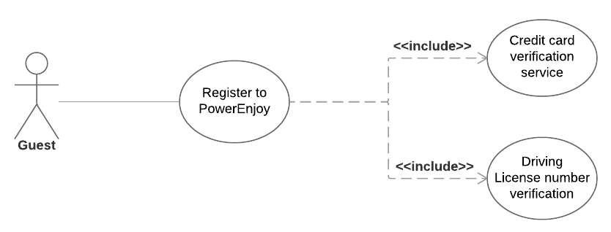

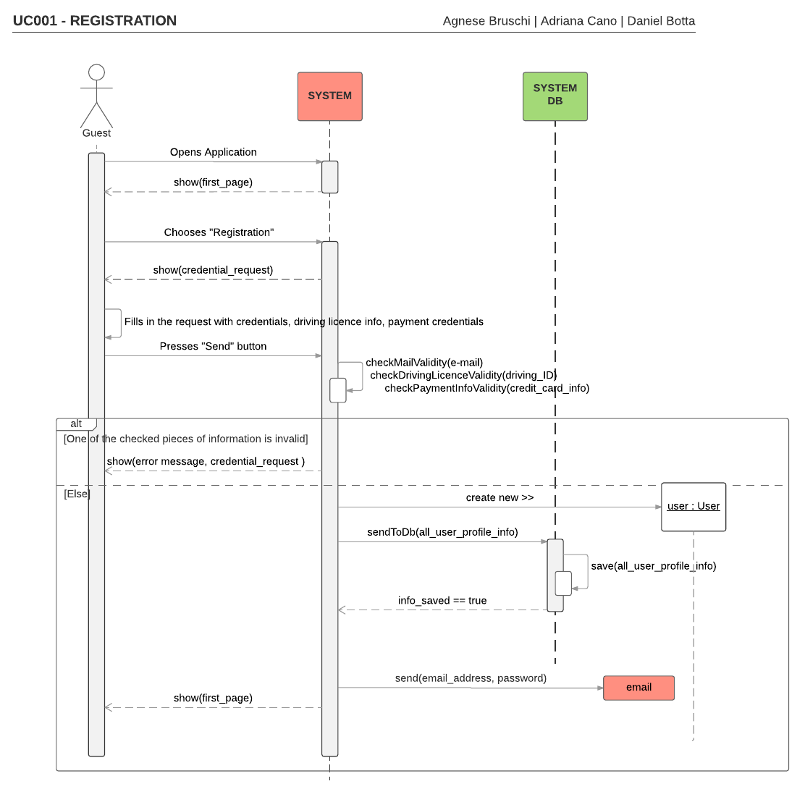

|  |  |
| --- | --- |
| Name | Login |
| Code | UC002 |
| Goal |  |
| Actors | User |
| Entry conditions | User would like to login. |
| Flow of events | The user opens the application and inserts his email and password. Then selects “Login”. |
| Exit conditions | The system shows him his profile |
| Exceptions | Username and/or password don’t match. An error message is shown, along with the first page of the application, to restart. |

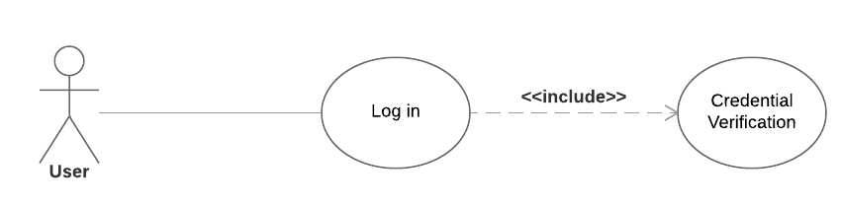

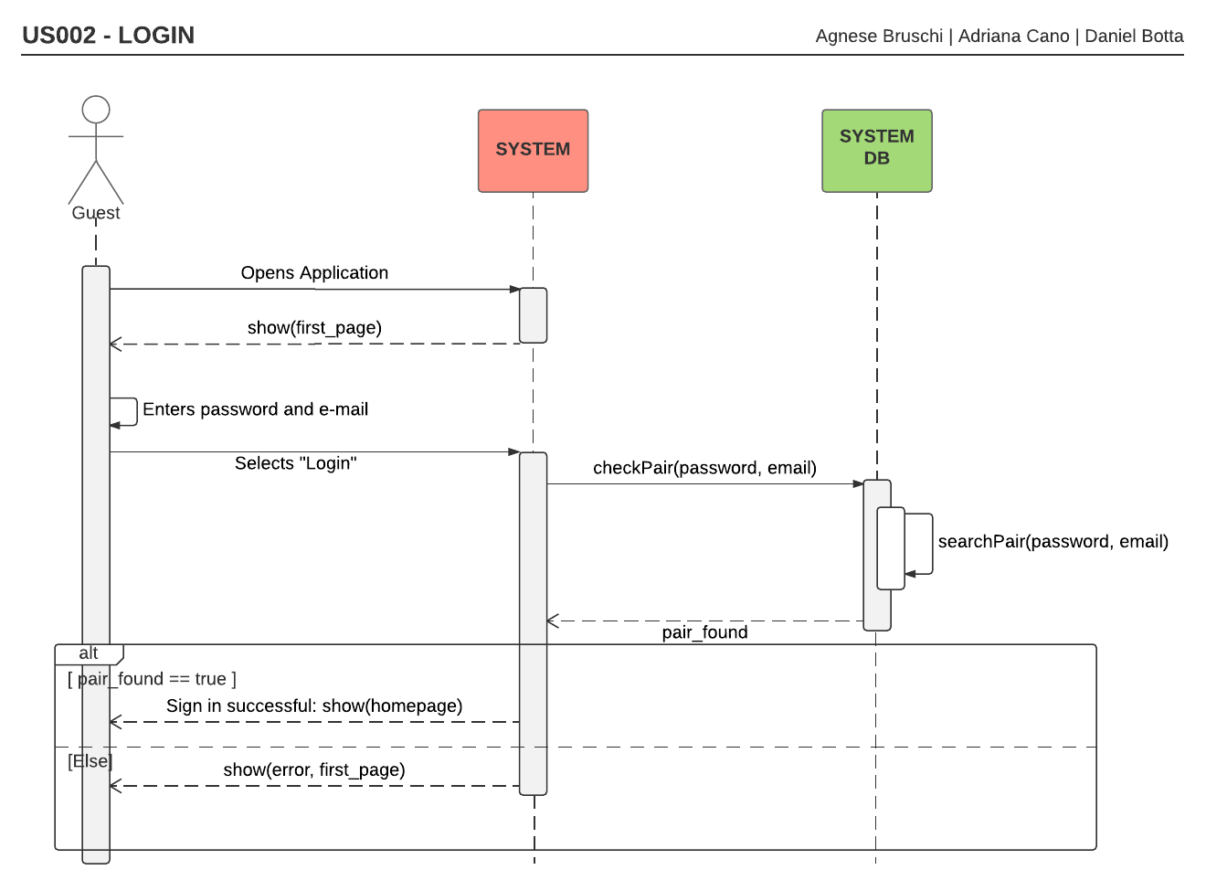

|  |  |
| --- | --- |
| Name | Visualize profile |
| Code | UC003 |
| Goal |  |
| Actors | User |
| Entry conditions | * Logged in correctly * Selected “Profile” |
| Flow of events | Just visual. No actions required |
| Exit conditions | If another option is chosen |
| Exceptions | No exception |

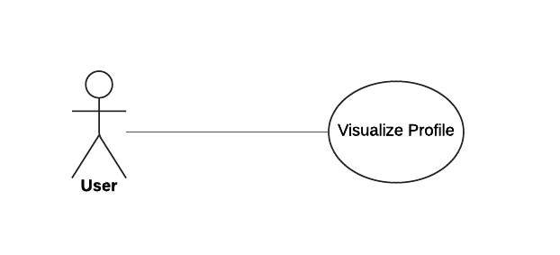

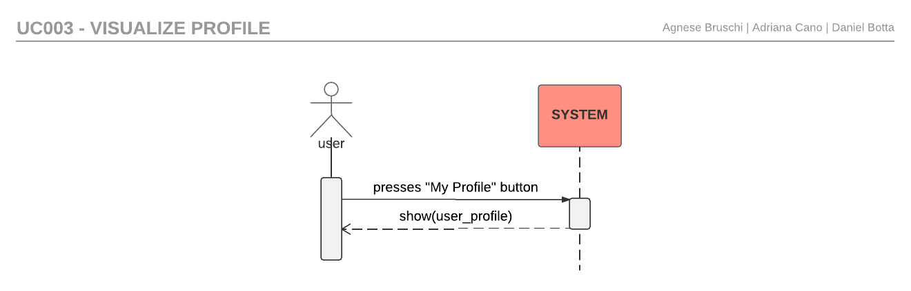

|  |  |
| --- | --- |
| Name | Modify personal information |
| Code | UC004 |
| Goal |  |
| Actors | User |
| Entry conditions | User must be logged in. |
| Flow of events | User selects “Modify personal information”. The system then shows him a form to complete with:  email, credit card information and driving license. When finished, the user can select “save changes” to conclude the operation, and the changed profile is shown. |
| Exit conditions | “Save changes” option has been selected. |
| Exceptions | * If one or more fields aren’t filled * If credit card or driving license number isn’t valid |

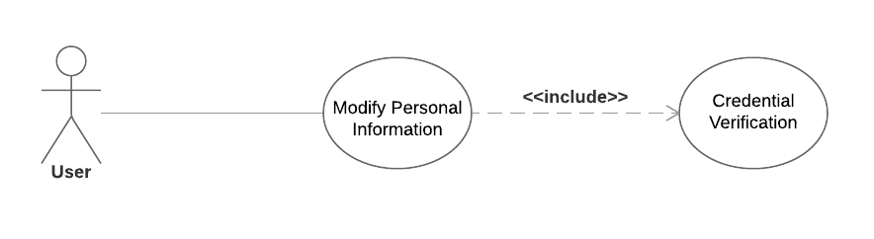

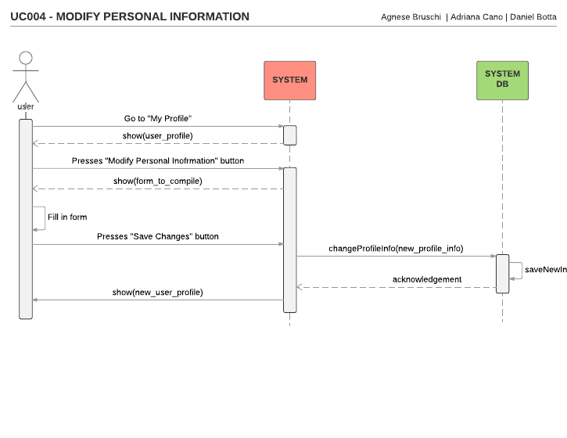

|  |  |
| --- | --- |
| Name | Search for a car |
| Code | UC005 |
| Goal |  |
| Actors | User |
| Entry conditions | Used logged in and has selected “Search” option |
| Flow of events | The user selects the radius from which to search for cars. Selects the location from where to search.The system processes the input given and retrieves a list of available cars for the user to select. |
| Exit conditions | * Application is closed * User chooses other options * User finishes the operation |
| Exceptions | No exception. |

|  |  |
| --- | --- |
| Name | Reserve car |
| Code | UC006 |
| Goal |  |
| Actors | User |
| Entry conditions | User must have just searched for a car. |
| Flow of events | Once the user has decided the car to reserve he can select it to reserve it.He must select the time he would like to reserve it for. Once the operation is completed a reservation code is saved in the user’s profile. He can visualize it when he desires |
| Exit conditions | * Application is closed * User chooses other options * User finishes the operation |
| Exceptions | If the user has already reserved a car. Only one reservation is permitted |

|  |  |
| --- | --- |
| Name | Pick up a car |
| Code | UC007 |
| Goal |  |
| Actors | User |
| Entry conditions | The user is located next to the car he reserved and he has his reservation code, which can be found in his profile. |
| Flow of events | The user inserts the reservation code into the car. If it’s correct the system unlocks the car and he can enter. |
| Exit conditions | Code is correct |
| Exceptions | Code is incorrect. If this occurs 3 times the car will become available once again and has to be reserved for use. |

|  |  |
| --- | --- |
| Name | Cancel reservation |
| Code | UC008 |
| Goal |  |
| Actors | User |
| Entry conditions | User logged in and on his profile page |
| Flow of events | User can select the reservation he has and choose “Cancel reservation” to cancel it. |
| Exit conditions | * Application is closed * User chooses other options * User finishes the operation |
| Exceptions | No exceptions |

|  |  |
| --- | --- |
| Name | Pending State Option |
| Code | UC009 |
| Goal |  |
| Actors | User |
| Entry conditions | User must have parked the car and selected “Pending” on the reservation page. |
| Flow of events | Once he leaves the vehicle, the car will go in a “Pending” state. In this state the fee will be reduced by 30%. |
| Exit conditions | User turns on the engine, or deactivates from the application. |
| Exceptions | No exceptions. |

|  |  |
| --- | --- |
| Name | Money saving option |
| Code | UC010 |
| Goal |  |
| Actors | User |
| Entry conditions | User logged in and has selected “Money saving option” |
| Flow of events | User can choose a destination. The system will process the input and retrieve a location of where to leave the car once finished using it. This will provide a discount on the last ride. |
| Exit conditions | * Application is closed * User chooses other options * User finishes the operation |
| Exceptions | No exceptions. |

|  |  |
| --- | --- |
| Name | Two Passenger Discount |
| Code | UC011 |
| Actors | User |
| Goal |  |
| Entry conditions | User has started and finished their last ride with at least two passengers other than him/her. |
| Flow of events | The car sensor detects the number of passengers on the car during the whole ride.  Once the car has been parked in the safe area a notification is sent to the user. He is informed that he will get a 10% discount on his last ride due to the “Two Passenger Discount” |
| Exit conditions | Just visual. No actions required |
| Exceptions | If the passengers exits the vehicle and for a part of the ride there are less than two |

|  |  |
| --- | --- |
| Name | Half Battery Discount |
| Code | UC012 |
| Actors | User |
| Goal |  |
| Entry conditions | User has finished ride with at least 50% battery left |
| Flow of events | Once the car has been parked in the safe area a notification is sent to the user. He is informed that he will get a 20% discount on his last ride due to the “Half Battery Discount” |
| Exit conditions | Just visual. No actions required |
| Exceptions | No exceptions. |

|  |  |
| --- | --- |
| Name | Power Grid Discount |
| Code | UC013 |
| Goal |  |
| Actors | User |
| Entry conditions | User has parked the car in a special parking area |
| Flow of events | Once the car has been parked in the safe area a notification is sent to the user. He is informed that he will get a 30% discount on his last ride due to the “Power Grid Discount” |
| Exit conditions | Just visual. No actions required |
| Exceptions | No exceptions. |

|  |  |
| --- | --- |
| Name | Penalty |
| Code | UC014 |
| Actors | User |
| Goal |  |
| Entry conditions | User has parked car at least 3 KM away from power grids, or has left the car with only 20% battery remaining |
| Flow of events | Once the car has been parked in the safe area a notification is sent to the user. He is informed that he will get a 30% increase of price on his last ride due to the “Penalty” |
| Exit conditions | Just visual. No actions required |
| Exceptions | No exceptions. |

|  |  |
| --- | --- |
| Name | Field Operator Work |
| Code | UC015 |
| Goal |  |
| Actors | Field Operator |
| Entry conditions | Notification has arrived on his profile. |
| Flow of events | The operator checks the notification. He gathers information about car location, type of work. He then travels to the location with the right equipment and does his work |
| Exit conditions | Finishes his work |
| Exceptions | No exceptions. |

Performance requirements

The software product requires that every web page shall download in 10 seconds or less.

3.4 Design constraints

The software product must be designed and implemented with JEE technologies, in particular EJBs for the business logic.

3.5 Software system attributes

3.5.1 Reliability

The software product ensures reliability in the maintenance of the data and the operations of payment.

3.5.2 Availability

The system shall be available 24 hours per day,7 days a week.

3.5.3 Security

The software product shall provide secure storage of the personal information inserted as well as the password generated which is used to access the personal account.

3.5.4 Maintainability

The database has a backup of the information in use and it is periodically updated so that in case of malfunction there is no data loss.

3.5.5 Portability

The software product can be installed in any smartphone that supports the java virtual machine and its dependent components.

3.6 Other requirements

The software product must inform and instruct the user in case of errors through clear textual messages.

Alloy model

In the next paragraph we will introduce the Alloy model written for our application in order to check the integrity of elements compounding our system and how they interact with one another.

module powerEnJoy

/*****************************USER****************************/

sig User{

userID: UserID,

searches: set CarSearch,

reserves: set Reservation

}{

#reserves <= #searches

}

one sig UserLog{

users: set User

}{

users=User

}

abstract sig ID {}

sig UserID extends ID{}

sig OperatorID extends ID{}

/**************************CAR***********************************/

sig Car{

plate: Int,

state: CarState,

locked: CarLocking,

location: Area

}{

plate>0

}

abstract sig State{}

abstract sig CarState extends State{}

sig Available extends CarState{}

sig Reserved extends CarState{}

sig Maintenance extends CarState{}

sig InUse extends CarState{}

sig Pending extends CarState{}

abstract sig CarLocking extends State {}

sig Locked extends CarLocking{}

sig UnLocked extends CarLocking{}

sig TempLocked extends CarLocking{}

sig ChargingPoint{}{

ChargingPoint=SafeArea.chargingPoint

}

abstract sig Area {

coordinates: some Position

}

sig OtherArea extends Area{}

sig SafeArea extends Area{

chargingPoint: lone ChargingPoint

}

/**********************Reservation*********************************/

sig Reservation{

resID: Int,

state: ReservationState,

car: Car

}{

resID>0

}

abstract sig ReservationState extends State{}

sig Valid extends ReservationState{}

sig Confirmed extends ReservationState{}

sig Frozen extends ReservationState{}

sig Completed extends ReservationState{}

sig Cancelled extends ReservationState{}

/****************************CarSearch****************************/

sig CarSearch{

firstRange: FirstRange,

secondRange: SecondRange,

thirdRange: ThirdRange,

address: Position,

reserve: lone Reservation

}

sig Position{}

abstract sig Range{

coverage: some Position,

centralPosition: Position,

cars: set Car,

radius: one Int

}

sig FirstRange extends Range{

}{

int radius=1}

**sig** SecondRange extends Range{

}{

int radius=2}

sig ThirdRange extends Range{

}{

int radius=4}

/************************ReservationBook**************************/

//Container of all the reservations of the system

one sig ReservationBook{

reservations: set Reservation

}{

reservations=Reservation

}

/****************************FieldOperator************************/

sig FieldOperator{

operatorID: OperatorID,

handling: lone Car

}

/******************************FACTS***************************/

fact userProperties{

//Unique ID for every user

all disjoint u1, u2: User | u1.userID!=u2.userID

//A user can't have two different reservations going on at the same time

all u: User {no disjoint r1,r2: Reservation| hasReserved[u, r1] && hasReserved[u, r2] && r1.state in Valid + Confirmed && r2.state in Valid +Confirm}

}

fact uniquePlates{

no disj c1,c2: Car | c1.plate=c2.plate

}

fact ids{

no disjoint fo1,fo2: FieldOperator | fo1.operatorID=fo2.operatorID

}

fact locations{

//Two cars can not be in the same area at the same time

no disj c1,c2: Car | c1.location=c2.location

//The cars in a search result are all centered in the requested address

all s: CarSearch | s.address=s.firstRange.centralPosition + s.secondRange.centralPosition +s.thirdRange.centralPosition

all disjoint s1,s2: SafeArea{no cp: ChargingPoint | cp in s1.chargingPoint && cp in s2.chargingPoint}

all disjoint a1,a2: Area {no p1: Position | p1 in a1.coordinates && p1 in a2.coordinates}

}

fact reservationProperties{

//Unique reservation number for each reservation

no disjoint r1,r2: Reservation | r1.resID=r2.resID

//For every reservation there exists a search that led to it

all r: Reservation {one s: CarSearch | searchTurnedReservation[s,r]}

//The search and the reservation in a association have the same qualities

all r: Reservation{one s: CarSearch| one u: User |hasReserved[u,r] && hasSearched[u,s] && carBelongsToSearch[r.car, s] }

//A reservation is done only by one user

all r: Reservation {one u: User | hasReserved[u,r]}

}

fact reservationStatePropertie{

//A reservation is valid the instance after is being created until the car is unlocked by the reservee or until the reservation is cancelled

all r: Reservation | r.state in Valid <=> r.car.state in Reserved && r.car.locked in Locked && r.car.location in SafeArea

//A reservation is Confirmed the moment the reservee unlocks said car

all r: Reservation | r.state in Confirmed <=> r.car.state in InUse && r.car.locked in UnLocked && r.car.location in OtherArea

//After a user is done with the car, the car can be in two types of conditions: Low battery, with mainatance problems so in Maintance

// or the user has a stellar behavior and the car is Available for yet another reservation

all r: Reservation | r.state in Completed <=> r.car.state in Maintenance + Available && r.car.locked in Locked && r.car.location in SafeArea

//A reservation is Canceled if the user doesn't pick up the car in time or if the user himself/herself canceles the reservation

all r: Reservation | r.state in Cancelled <=> r.car.state in Available && r.car.locked in Locked && r.car.location in SafeArea

//A reservation is Frozen if the user decides to make a stop but is not done with his/her reservation

all r: Reservation | r.state in Frozen <=> r.car.state in Pending && r.car.locked in TempLocked && r.car.location in SafeArea + OtherArea

}

fact generalFacts{

Car= Reservation.car +FirstRange.cars + SecondRange.cars +ThirdRange.cars

ReservationState= Reservation.state

Area=Car.location

CarState=Car.state

CarLocking=Car.locked

CarSearch=User.searches

Reservation=User.reserves

User=UserLog.users

FirstRange=CarSearch.firstRange

SecondRange=CarSearch.secondRange

ThirdRange=CarSearch.thirdRange

UserID=User.userID

OperatorID=FieldOperator.operatorID

FirstRange.coverage in SecondRange.coverage

SecondRange.coverage in ThirdRange.coverage

Position= FirstRange.coverage + SecondRange.coverage + ThirdRange.coverage + Area.coordinates

CarState=Available + InUse + Pending + Reserved + Maintenance

CarLocking=Locked + UnLocked + TempLocked

ReservationState= Valid + Confirmed + Completed + Cancelled + Frozen

ChargingPoint=SafeArea.chargingPoint

}

fact carStateProperties{

//An available car is a car that appears on the searches the user can make and it is locked

all c: Car{c.state in Available => {no r: Reservation | r.car=c }}

all c: Car {c.state in Available =>c.locked in Locked

&& c in FirstRange.cars + SecondRange.cars + ThirdRange.cars && c.location in SafeArea}

all c: Car{c.state in Available => no fo: FieldOperator | c in fo.handling}

// A car is Reserved if there is a user that has reserves it. A reserved car is still Locked

all c: Car { c.state in Reserved => {one r: Reservation|r.car=c && r.state in Valid }}

all c: Car {c.state in Reserved =>c.locked in Locked && c.location in SafeArea}

all c: Car{c.state in Reserved => no fo: FieldOperator | c in fo.handling}

//A car is in use if there exists a confirmed reservation, the car in unlocked and not located in a SafeArea

all c: Car { c.state in InUse <=> {one r: Reservation | r.car=c

&& r.state in Confirmed && c.locked in UnLocked

&& c.location in OtherArea }}

all c: Car{c.state in InUse => no fo: FieldOperator | c in fo.handling}

//A car is Pending if the reservee makes a stop but the reservation is ongoing. He can park the car in a non Safe area.

all c: Car{c.state in Pending <=>{one r: Reservation | c.locked in TempLocked

&& r.car=c && r.state in Frozen}}

all c: Car{c.state in Pending => no fo: FieldOperator | c in fo.handling}

//A car is said to be in maintanance if it is being handled by a FieldOperator or if it is charging

all c: Car {c.state in Maintenance => {no r: Reservation |r.car=c }}

all c: Car {c.state in Maintenance => {some fo: FieldOperator | c in fo.handling } || #c.location.chargingPoint=1}

all c: Car {c.state in Maintenance => c.location in SafeArea && c.locked in UnLocked }

all c: Car{c.state in Maintenance => c not in FirstRange.cars + SecondRange.cars + ThirdRange.cars }

all c: Car{c.state in Maintenance => no fo: FieldOperator | c in fo.handling}

all c: Car{c not in FirstRange.cars + SecondRange.cars + ThirdRange.cars => c.state in Maintenance + Reserved + InUse + Pending}

}

fact rangeProp{

all s: CarSearch {all c: Car | c in s.firstRange.cars <=> c.location.coordinates in s.firstRange.coverage }

all s: CarSearch {all c: Car | c in s.secondRange.cars <=> c.location.coordinates in s.secondRange.coverage }

all s: CarSearch {all c: Car | c in s.thirdRange.cars <=> c.location.coordinates in s.thirdRange.coverage }

}

/**************************PREDICATES**************************/

pred hasReserved [u: User, r: Reservation]{

r in u.reserves

}

pred hasSearched[u: User, s: CarSearch]{

s in u.searches

}

pred searchTurnedReservation[s: CarSearch, r: Reservation]{

r in s.reserve

}

pred carBelongsToSearch[c: Car, s: CarSearch]{

c in s.firstRange.cars +s.secondRange.cars + s.thirdRange.cars

}

assert reservationCheck{

no r: Reservation {no s: CarSearch| searchTurnedReservation[s,r]}

no r: Reservation {one c: Car | r.car=c && c.state in Maintenance}

all r: Reservation {no c: Car | r.car=c && r.state in Completed && c.state not in Available}

all r: Reservation {no c: Car | r.car=c && r.state in Cancelled && c.state not in Available}

all r: Reservation {no c: Car | r.car=c && r.state in Confirmed && c.state not in InUse}

all r: Reservation {no c: Car | r.car=c && r.state in Valid && c.state not in Reserved}

}

assert carCheck{

no c: Car {one r: Reservation | c.location in SafeArea && r.car=c && r.state in Confirmed}

no c: Car | c.state in Available && c.locked in UnLocked + TempLocked

no c: Car | c.state in Reserved && c.locked in UnLocked + TempLocked

no c: Car | c.state in InUse && c.locked in Locked + TempLocked

no c: Car | c.state in Maintenance && c.locked in Locked + TempLocked

no c: Car | c.state in Pending && c.locked in UnLocked + Locked

no c: Car | c.location in SafeArea && c.locked in TempLocked

no c: Car | c.location in OtherArea && c.locked in Locked

no c: Car | c.state in Available + Reserved + Maintenance && c.location in OtherArea

no c: Car | c.state in InUse + Pending && c.location in SafeArea

no c: Car | c.state in Maintenance && c in FirstRange.cars + SecondRange.cars + ThirdRange.cars

}

pred show{

#User=3

#User.searches=3

#User.reserves=2

#ChargingPoint=1

}

run show

check reservationCheck for 3

check carCheck for 3

